Expt 3 | Performance Analysis of IIR Filters
Date | 3.1 Design and Comparative Analysis of Butterworth and Chebyshev Type-I IIR Band-Pass Filters Using MATLAB

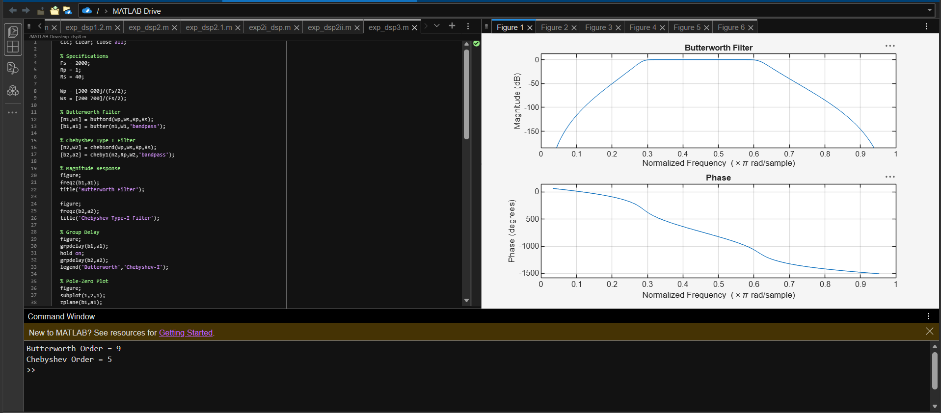
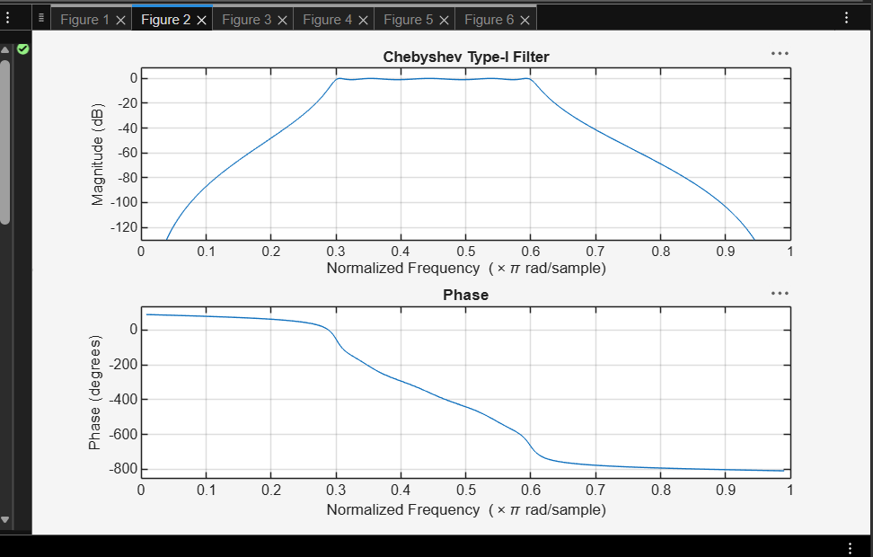
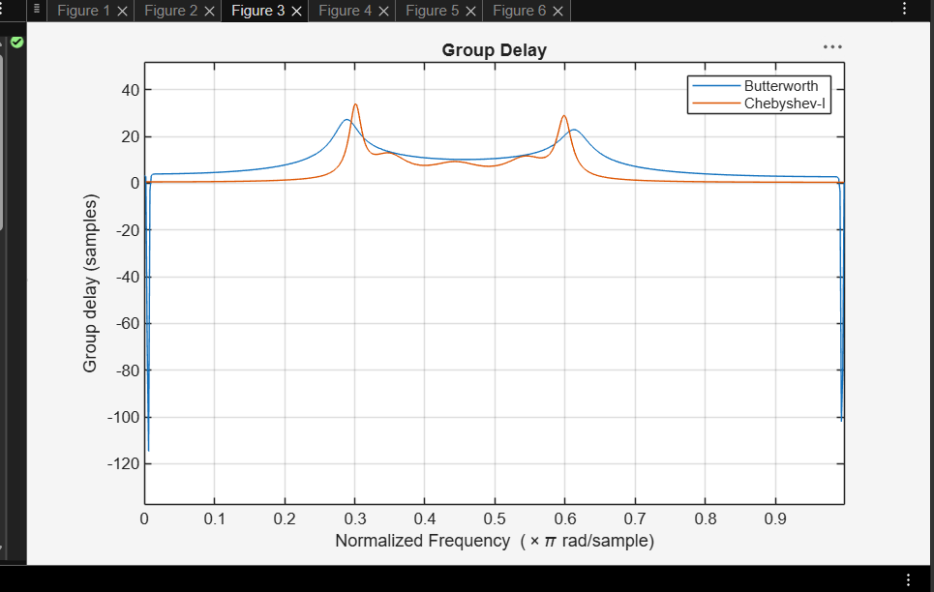
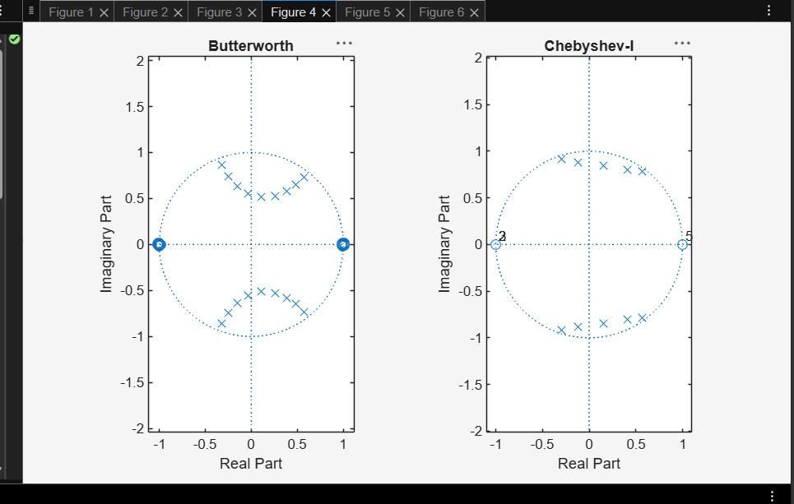
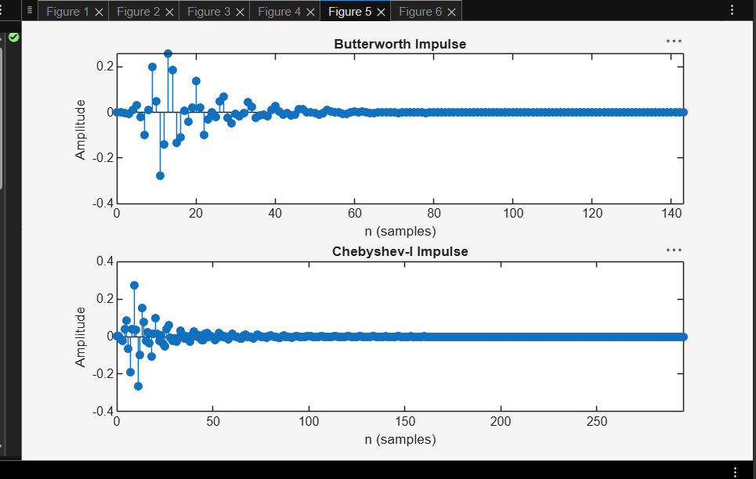
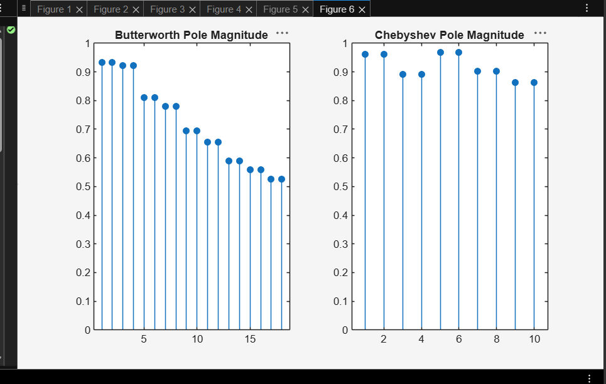

Results:
1. Butterworth and Chebyshev Type-I IIR Band-Pass Filters were successfully designed and implemented in MATLAB.
2. The minimum filter orders and cutoff frequencies were obtained for both filters. 3. The frequency responses were analyzed and compared; the Chebyshev filter provided a sharper transition, while the Butterworth filter showed a smoother response. 4. Pole-zero analysis confirmed that both filters are stable and satisfy the given design specifications.

